# Wholeness of Data Analytics



*1*

Learning Objectives

* Understand Business Intelligence and Data Mining Cycle
* Learn about the tools and purpose of Business Intelligence
* Discover what are patterns, their types, and the process of discovering patterns
* Understand the data processing chain
* Learn in brief about the components of the data processing chain
* Process a simple example dataset through complete data processing chain
* Learn about datafication and various types of data
* Learn in brief about key terms and Data Science careers

### INTRODUCTION

Business is the act of doing something productive to serve someone’s needs and thus earn a living and make the world a better place. Business activities are recorded on paper or using electronic media, and then these records become data. There is more data from customers’ responses and on the industry. All this data can be analyzed and mined using special tools and techniques to generate patterns and intelligence, which reflect how the business is functioning. These ideas can then be fed back into the business so that it can evolve to become more effective and efficient in serving customer needs; and the cycle goes on figure.

Business

Intelligence

Mining

Data

Business Intelligence and Data Mining (BIDM) Cycle

### BUSINESS INTELLIGENCE

Any business organization needs to continually monitor its business environment and its own performance, and then rapidly adjust its future. This includes monitoring the industry, competitors, suppliers, and customers. The organization also needs to develop a balanced scorecard to track its own health and vitality. Executives typically determine what they want to track based on their Key Performance Indexes (KPIs) or Key Result Areas (KRAs). Customized reports need to be designed to deliver the required information to every executive. These reports can be converted into customized dashboards that deliver the information rapidly and in easy-to-grasp formats.

#### Caselet: MoneyBall – Data Mining in Sports

*Analytics in sports was made popular by the book and movie, Moneyball. Statistician Bill James and Oakland A’s general manager, Billy Bean, placed emphasis on crunching numbers and data instead of watching an athlete’s style and looks. Their goal was to make a team better while using fewer resources. The key action plan was to pick important role players at a lower cost while avoiding the famous players who demand higher salaries but may provide a low return on a team’s in- vestment. Rather than relying on the scouts’ experience and intuition, Bean selected players based almost exclusively on their on-base percentage (OBP). By finding players with a high OBP but with characteristics that lead scouts to dismiss them, Bean assembled a team of undervalued players with far more potential than the A’s hamstrung finances would otherwise allow.*

*Using this strategy, they proved that even small market teams can be competitive – a case in point, the Oakland A’s. In 2004, two years after adopting the same sabermetric model, the Boston Red Sox won their first World Series since 1918. (Source: Moneyball, 2004).*

1. *Could similar techniques be applied to the games of soccer or cricket? If so, how?*
2. *What are the general lessons from this story?*

Business intelligence is a broad set of information technology (IT) solutions that includes tools for gathering, analyzing, and reporting information to the users about performance of the organization and its environment. These IT solutions are among the most highly prioritized solutions for investment.

Consider a retail business chain that sells many kinds of goods and services around the world, online and in physical stores. It generates data about sales, purchases, and expenses from multiple locations and time frames. Analyzing this

data could help identify fast-selling items, regional-selling items, seasonal items, fast-growing customer segments, and so on. It might also help generate ideas about what products sell together and which people tend to buy which products. These insights and intelligence can help design better promotion plans, product bundles, and store layouts, which in turn lead to a better-performing business.

The vice president of sales of a retail company would want to track the sales to date against monthly targets, the performance of each store and product category, and the top store managers for that month. The vice president of finance would be interested in tracking daily revenue, expense, and cash flows by store; comparing them against plans; measuring cost of capital; and so on.

### PATTERN RECOGNITION

A pattern is a design or model that helps grasp something. Patterns help connect things that may not appear to be connected. Patterns help cut through complexity and reveal simpler understandable trends. They can be as definitive as hard scientific rules, like the rule that the Sun always rises in the east. They can also be simple generalizations, such as the Pareto principle, which states that 80 percent of effects come from 20 percent of the causes.

A perfect pattern or model is the one that (a) accurately describes a situation,

(b) is broadly applicable, and (c) can be described in a simple manner.

*E* = *MC*2 would be such a general, accurate, and simple (GAS) model. Very often, all three qualities are not achievable in a single model, and one must settle for two of the three qualities in the model.

### Types of Patterns

Patterns can be temporal, which is something that regularly occurs over time. Patterns can also be spatial, such as things being organized in a certain way. Patterns can be functional, which means doing certain things leads to certain effects. Good patterns are often symmetric. They echo basic structures and pat- terns that we are already aware of.

A temporal rule would be that “some people are always late,” no matter what the occasion or time. Some people may be aware of this pattern and some may not. Understanding a pattern like this would help dissipate a lot of unnecessary frustration and anger. One can just joke that some people are born “10 minutes late,” and laugh it away. Similarly, Parkinson’s Law states that work expands to fill up all the time available to do it.

A spatial pattern, following the 80–20 rule, could be that the top 20 percent of customers lead to 80 percent of the business; or 20 percent of products generate 80 percent of the business; or 80 percent of incoming customer service calls are related to just 20 percent of the products. This last pattern may simply reveal a discrepancy between a product’s features and what the customers believe about the product. The business can then decide to invest in educating the customers better so that the customer service calls can be significantly reduced.

A functional pattern may involve test-taking skills. Some students perform well on essay-type questions. Others do well in multiple-choice questions. Yet other students excel in doing hands-on projects, or in oral presentations. An awareness of such a pattern in a class of students can help the teacher design a balanced testing mechanism that is fair to all.

However, long-established patterns can also be broken. The past cannot always predict the future. A pattern like “all swans are white” does not mean that there may not be a black swan. Once enough anomalies are discovered, the underlying pattern itself can shift. The economic meltdown in 2008–2009 was because of the collapse of the accepted pattern, that is, “housing prices always go up.” A deregulated financial environment made markets more volatile and led to greater swings in markets, leading to the eventual collapse of the entire financial system.

### Finding a Pattern

Diamond mining is the act of digging into large amounts of unrefined ore to dis- cover precious gems or nuggets. Similarly, data mining is the act of digging into large amounts of raw data to discover unique nontrivial useful patterns. Data is cleaned up, and then special tools and techniques can be applied to search for patterns. Diving into clean and nicely organized data from the right perspectives can increase the chances of making the right discoveries.

A skilled diamond miner knows what a diamond looks like. Similarly, a skilled data miner should know what kinds of patterns to look for. The patterns are essentially about what hangs together and what is separate. Therefore, knowing the business domain well is very important. It takes knowledge and skill to discover the patterns. It is like finding a needle in a haystack. Sometimes the pattern may be hiding in a plain sight. At other times, it may take a lot of work and looking far and wide, to find surprising useful patterns. Thus, a systematic approach to mining data is necessary to efficiently reveal valuable insights.

### Uses of Pattern

When used in clever ways, data mining can lead to interesting insights and be a source of new ideas and initiatives.

Retaining students is an ongoing challenge for universities. Recent data-based research shows that students leave a school for social reasons more than they do for academic reasons. This pattern/insight can instigate schools to pay closer attention to students engaging in extracurricular activities and developing stronger bonds at school. The school can invest in entertainment activities, sports activities, camping trips, and other activities. The school can also begin to actively gather data about every student’s participation in those activities, to predict at-risk students and take corrective action.

As another instance, the attitude of employees towards their employer may be hypothesized to be determined by many factors, such as level of education, income, tenure in the company, and gender. It may be surprising if the data reveals that the attitudes are determined first and foremost by their age bracket. Such a simple insight could be powerful in designing organizations effectively. The data miner must be open to all possibilities.

One can predict the traffic pattern on highways from the movement of cell phone (in the car) locations on the highway. If the locations of cell phones on a highway or roadway are not moving fast enough, it may be a sign of traffic congestion. Telecom companies can thus provide real-time traffic information to the drivers on their cell phones, or on their GPS devices, without the need of any video cameras or traffic reporters.

Similarly, organizations can find out an employee’s arrival time at the office by when their cell phone shows up in the parking lot. Observing the record of the swipe of the parking permit card in the company parking garage, can inform the organization whether an employee is in the office building or out of the office at any moment in time.

Some patterns may be so sparse that a very large amount of diverse data must be seen together to notice any connections. For instance, locating the debris of a flight that may have vanished midcourse would require bringing together data from many sources, such as satellites, ships, and navigation systems. The raw data may come with various levels of quality and may even be conflicting. The data at hand may or may not be adequate for finding good patterns. Additional dimensions of data may need to be added to help solve the problem.

### DATA PROCESSING CHAIN

Data is the new natural resource. Implicit in this statement is the recognition of hidden value in data. Data lies at the heart of business intelligence. There is a sequence of steps to be followed to benefit from the data in a systematic way.

Data can be modeled and stored in a database. Relevant data can be extracted from the operational data stores according to certain reporting and analyzing purposes and stored in a data warehouse. The data from the warehouse can be combined with other sources of data and mined using data mining techniques to generate new insights. The insights need to be visualized and communicated to the right audience in real time for competitive advantage. Figure below explains the progression of data processing activities. The rest of this chapter covers these five elements in the data processing chain.



Data Visualization

Data Mining

Data Warehouse

Data Base

Data

Data Processing Chain

*Data*

Anything that is recorded is data. Observations and facts are data; anecdotes and opinions are also data, of a different kind. Data can be numbers, like the record of daily weather, or daily sales. Data can be alphanumeric, such as the names of employees and customers.

* Data can come from any number of sources – from operational records in- side an organization, or from records compiled by the industrial bodies and government agencies. Data can come from individuals telling stories from memory and from people’s interaction in social contexts, or from machines reporting their own status or from logs of web usage.
* Data can come in many ways – it may come as paper reports, or as a file stored on a computer. It may be words spoken over the phone. It may be e-mail or chat on the Internet or may come as movies and songs in DVDs, and so on.
* There is also data about data that is called metadata. For example, people regularly upload videos on YouTube. The format of the video file (whether high resolution or lower resolution) is metadata. The information about the time of uploading is metadata. The account from which it was uploaded is also metadata. The record of downloads of the video is also metadata.

Data can be of different types described as follows

* Data can be an unordered collection of values. For example, a retailer sells shirts of red, blue, and green color. There is no intrinsic ordering among these color values. One can hardly argue that any one color is higher or lower than the other. This is called nominal data.
* Data can also be ordered values like small, medium and large. For example, the sizes of shirts can be extra-small, small, medium, and large. There is clarity that medium is bigger than small, and large is bigger than medium. But the differences may not be equal. This is called ordinal (ordered) data.
* Another type of data has discrete numeric values defined in a certain range with the assumption of equal distance between the values. Customer satisfaction score may be ranked on a 10-point scale with 1 being lowest and 10 being highest. This requires the respondent to carefully calibrate the entire range as objectively as possible and place his own measurement in that scale. This is called interval (equal intervals) data.
* The highest level of numeric data is the ratio data which can take on any numeric value. The weights and heights of all employees would be exact numeric values. The price of a shirt will also take any numeric value. It is called ratio (any fraction) data.
* There is another kind of data that does not lend itself to much mathematical analysis, at least not directly. Such data needs to be first structured and then analyzed. This includes data like audio, video, and graph files, often called BLOBs (Binary Large Objects). These kinds of data lend themselves to different forms of analysis and mining. Songs can be described as happy or sad, fast-paced or slow, and so on. They may contain sentiment and intention, but these are not quantitatively precise.

The precision of analysis increases as data becomes more numeric. Ratio data can be subjected to rigorous mathematical analysis. For example, precise weather data about temperature, pressure, and humidity can be used to create rigorous mathematical models that can accurately predict future weather.

Data may be publicly available and sharable, or it may be marked private. Traditionally, the law allows the right to privacy concerning one’s personal data. There is a big debate on whether the personal data shared on social media conversations is private or can be used for commercial purposes.

*Datafication* is a new term which means that almost every phenomenon is now being observed and stored. More devices are connected to the Internet; more people are constantly connected to “the grid” by their phone network or the Internet, and so on. Every click on the web, and every movement of the mobile devices, is being recorded. Machines are generating data. The “Internet of things” is growing faster than the Internet of people. All of this is generating an exponentially growing volume of data at high velocity. Kryder’s law predicts that the density and capability of hard drive storage media will double every 18 months. As storage costs keep coming down at a rapid rate, there is a greater

incentive to record and store more events and activities at a higher resolution. Data is getting stored in a more detailed resolution, and many more variables are being captured and stored.

*Database*

A database is a modeled collection of data that is accessible in many ways. A data model can be designed to integrate the operational data of the organization. The data model abstracts the key entities involved in an action and their relation- ships. Most databases today follow the relational data model and its variants. Each data modeling technique imposes rigorous rules and constraints to ensure the integrity and consistency of data over time.

Take the example of a sales organization. A data model for managing customer orders will involve data about customers, orders, products, and their interrelationships. The relationship between the customers and orders would be such that one customer can place many orders, but one order will be placed by one and only one customer. It is called a one-to-many relationship. The relationship between orders and products is a little more complex. One order may contain many products. And one product may be contained in many different orders. This is called a many-to-many relationship. Different types of relationships can be modeled in a database.

Databases have grown tremendously over time. They have grown in complexity in terms of number of objects and their properties being recorded. They have also grown in the quantity of data being stored. A decade ago, a terabyte-sized database was considered big. Today databases are in petabytes and even exabytes. Video and other media files have greatly contributed to the growth of databases. E-commerce and other web-based activities also generate huge amounts of data. Data generated through social media has also generated large databases. The e-mail archives, including attached documents of organizations, are in similar large sizes.

Many Database Management Software Systems (DBMSs) are available to help store and manage this data. These include commercial systems, such as Oracle and DB2 system. There are also open-source, free DBMS, such as MySQL and PostgreSQL. These DBMSs help process and store millions of transactions worth of data every second.

Dataset shows a simple database of the sales of movies worldwide for a retail organization. It shows sales transactions of movies over three quarters. Using such a file, data can be added, accessed, and updated as needed.

|  |  |  |  |  |
| --- | --- | --- | --- | --- |
| Movies Transactions Database | | | | |
| Order No. | Date Sold | Product Name | Location | Amount |
| 1 | April 2015 | Monty Python | US | $9 |
| 2 | May 2015 | Gone With the Wind | US | $15 |
| 3 | June 2015 | Monty Python | India | $9 |
| 4 | June 2015 | Monty Python | UK | $12 |
| 5 | July 2015 | Matrix | US | $12 |
| 6 | July 2015 | Monty Python | US | $12 |
| 7 | July 2015 | Gone With the Wind | US | $15 |
| 8 | Aug 2015 | Matrix | US | $12 |
| 9 | Sept 2015 | Matrix | India | $12 |
| 10 | Sept 2015 | Monty Python | US | $9 |
| 11 | Sept 2015 | Gone With the Wind | US | $15 |
| 12 | Sept 2015 | Monty Python | India | $9 |
| 13 | Nov 2015 | Gone With the Wind | US | $15 |
| 14 | Dec 2015 | Monty Python | US | $9 |
| 15 | Dec 2015 | Monty Python | US | $9 |

*Data Warehouse*

A data warehouse is an organized store of data from all over the organization, specially designed to help make management decisions. Data can be extracted from operational database to answer a set of queries. This data, combined with other data, can be rolled up to a consistent granularity and uploaded to a separate data store called the data warehouse. Therefore, the data warehouse is a simpler version of the operational database, with the purpose of addressing reporting and decision-making needs only. The data in the warehouse cumulatively grows as more operational data becomes available and is extracted and appended to the data warehouse. Unlike in the operational database, the data values in the warehouse are not updated.

To create a simple data warehouse for the movies sales data, assume a simple objective of tracking sales of movies and making decisions about managing inventory. In creating this data warehouse, all the sales transaction data will be extracted from the operational data files. The data will be rolled up for all combinations of time period and product number. Thus, there will be one row for every combination of time period and product. The resulting data warehouse will look like the table that follows.

|  |  |  |  |
| --- | --- | --- | --- |
| Movies Sales Data Warehouse | | | |
| Row No. | Quarter Sold | Product Name | Amount |
| 1 | Q2 | Gone With the Wind | $15 |
| 2 | Q2 | Monty Python | $30 |
| 3 | Q3 | Gone With the Wind | $30 |
| 4 | Q3 | Matrix | $36 |
| 5 | Q3 | Monty Python | $30 |
| 6 | Q4 | Gone With the Wind | $15 |
| 7 | Q4 | Monty Python | $18 |

The data in the data warehouse is at much less detail than the transaction database. The data warehouse could have been designed at a lower or higher level of detail, or granularity. If the data warehouse was designed on a monthly level, instead of a quarterly level, there would be many more rows of data. When the number of transactions approaches millions and higher, with dozens of attributes in each transaction, the data warehouse can be large and rich with potential insights. One can then mine the data (slice and dice) in many ways and discover unique meaningful patterns. Aggregating the data helps improve the speed of analysis. A separate data warehouse allows analysis to go on separately in parallel, without burdening the operational database systems.

Comparing Database Systems with Data Warehousing Systems

|  |  |  |
| --- | --- | --- |
| Dimension | Database | Data Warehouse |
| Purpose | Data stored in databases can be used for many purposes including day-to-day operations. | Data stored in DW is a cleansed data useful for reporting and analysis. |
| Granularity | Highly granular data including all activity and transaction details. | Lower granularity data; rolled up to certain key dimensions of interest/ |
| Complexity | Highly complex with dozens or hundreds of data files linked through common data fields. | Typically organized around a large fact tables, and many lookup tables. |
| Size | Database grows with growing volumes of activity and transactions. Old completed transactions are deleted to reduce size. | Size grows as data from operational databases is rolled-up and appended every day. Data is retained for long- term trend analyses. |

(*Contd.*)

|  |  |  |
| --- | --- | --- |
| Architectural choices | Relational and object-oriented data- bases. | Star schema or Snowflake schema. |
| Data Access mechanisms | Primarily through high level languages such as SQL. Traditional programming access DB through Open DataBase Connectivity (ODBC) interfaces. | Accessed through SQL; SQL output is forwarded to reporting tools and data visualization tools. |

*Data Mining*

Data Mining is the art and science of discovering useful and innovative patterns from data. There is a wide variety of patterns that can be found in the data. There are many techniques, simple or complex, that help with finding patterns.

In this example, a simple data analysis technique can be applied to the data in the data warehouse described above. A simple cross-tabulation of results by quarter and products will reveal some easily visible patterns.

|  |  |  |  |  |
| --- | --- | --- | --- | --- |
| Movies Sales by Quarters – Cross-tabulation | | | | |
| Quarter/Product | Gone with the Wind | Matrix | Monty Python | Total Sales Amount |
| Q2 | $15 | 0 | $30 | $45 |
| Q3 | $30 | $36 | $30 | $96 |
| Q4 | $15 | 0 | $18 | $33 |
| Total Sales Amount | $60 | $36 | $78 | $174 |

Based on the cross-tabulation above, one can readily answer some product sales questions, like:

1. Which is the best-selling movie by revenue? – *Monty Python*
2. Which is the best quarter by revenue this year? – *Q3*
3. Any other patterns? – *Matrix movie sells only in Q3 (seasonal item)*

These simple insights can help plan marketing promotions and manage inventory of various movies.

If a cross tabulation was designed to include customer location data, one could answer other questions, such as

1. Which is the best-selling geography? – *US*
2. Which is the worst-selling geography? – *UK*
3. Any other patterns? – *‘Monty Python’ sells globally, while ‘Gone with the Wind’ sells only in the US*

If the data mining was done at the monthly level of data, it would be easy to miss the seasonality of the movies. However, one would have observed that September is the highest selling month.

The previous example shows that many differences and patterns can be noticed by analyzing data in different ways. However, some insights are more important than others. The value of the insight depends upon the problem being solved. The insight, that there are more sales of a product in a certain quarter, helps a manager plan what products to focus on. In this case, the store manager should stock up on Matrix in Quarter 3 (Q3). Similarly, knowing which quarter has the highest overall sales allows for different resource decisions in that quarter. In this case, if Q3 is bringing more than half of total sales, this requires greater attention on the e-commerce website in the third quarter.

Data mining should be done to solve high-priority, high-value problems. Much effort is required to gather data, clean and organize it, mine it with many techniques, interpret the results, and find the right insight. It is important that there be a large expected payoff from finding the insight. One should select the right data (and ignore the rest), organize it into a precise and imaginative framework that brings relevant data together, and then apply data mining techniques to deduce the right insight.

A retail company may use data mining techniques to determine which new product categories to add to which of their stores; how to increase sales of existing products; which new locations to open stores in; how to segment the customers for more effective communication, and so on.

Data can be analyzed at multiple levels of granularity and could lead to a large number of interesting combinations of data and interesting patterns. Some of the patterns may be more meaningful than the others. Such highly granular data is often used, especially in finance and high-tech areas, so that one can gain even the slightest edge over the competition.

Following are brief descriptions of some of the most important data mining techniques used to generate insights from data.

*Decision Trees* They help classify population into classes. It is said that 70 percent of all data mining work is about classification solutions, and that 70 percent of all classification work uses decision trees. Thus, decision trees are the most popular and important data mining technique. There are many popular algorithms to make decision trees. They differ in terms of their mechanisms and each technique work well for different situations. It is possible to try multiple decision tree algorithms on a dataset and compare the predictive accuracy of each tree.

*Regression* This is a well-understood technique from the field of statistics. The goal is to find a best fitting curve through many data points. The best fitting curve is that which minimizes the (error) distance between the actual data points

and the values predicted by the curve. Regression models can be projected into future for prediction and forecasting purposes.

*Artificial Neural Networks* Originating in the field of artificial intelligence and machine learning, ANNs are multi-layer, non-linear information processing models that learn from past data and predict future values. These models predict well, leading to their popularity. The model’s parameters may not be very intuitive. Thus, neural networks are opaque like a black-box. These systems also require a large amount of past data to effectively train the system.

*Cluster Analysis* This is an important data mining technique for dividing and conquering large datasets. The dataset is divided into a certain number of clusters, by discerning similarities and dissimilarities within the data. The user needs to decide by looking at how well the number of clusters chosen fits the data. This is most used for market segmentation. Unlike decision trees and regression, there is no one right answer for cluster analysis.

*Association Rule Mining* Also called Market Basket Analysis when used in retail industry, these techniques look for associations between data values. An analysis of items frequently found together in a market basket can help cross- sell products and create product bundles.

*Data Visualization*

As data and insights grow in number, a new requirement is the ability of the executives and decision makers to absorb this information in real time. There is a limit to human comprehension and visualization capacity. That is a good reason to prioritize and manage with fewer but key variables that relate directly to the Key Result Areas (KRAs) of a role.

Here are a few considerations when presenting using data:

* Present the conclusions and not just report the data.
* Choose wisely from a palette of graphs to suit the data.
* Organize the results to make the central point stand out.
* Ensure that the visuals accurately reflect the numbers. Inappropriate visuals can create misinterpretations and misunderstandings.
* Make the presentation unique, imaginative and memorable.

Executive dashboards are designed to provide information on select few variables for every executive. They use graphs, dials, and lists to show the status of important parameters. These dashboards also have a drill-down capability to enable a root-cause analysis of exception situations figure.

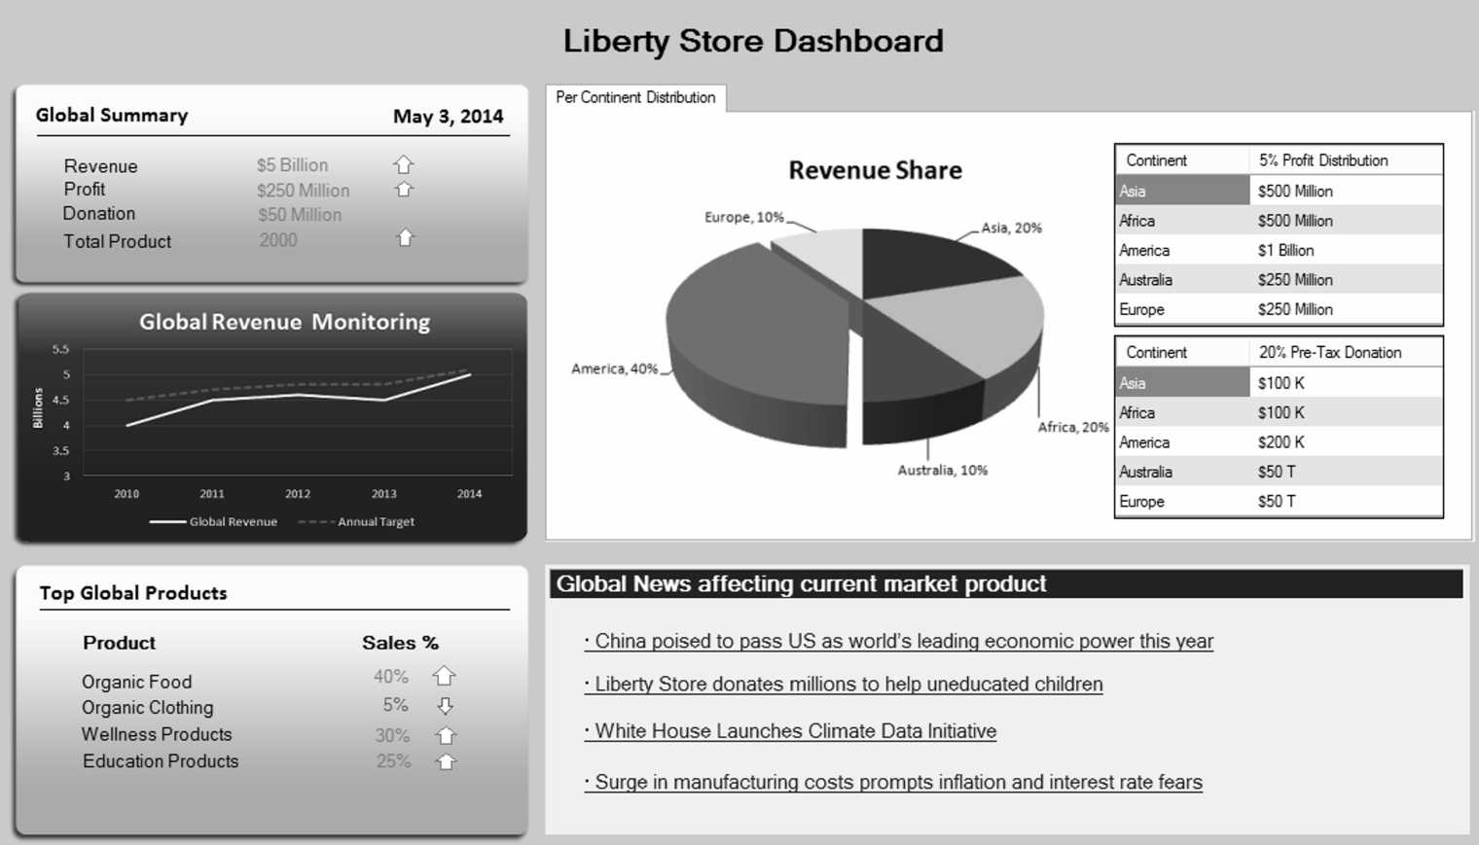

Sample Executive Dashboard

Data visualization has been an interesting problem across the disciplines. Many dimensions of data can be effectively displayed on a two-dimensional surface to give a rich and more insightful description of the totality of the story.

The classic presentation of the story of Napoleon’s march to Russia in 1812, by French cartographer Joseph Minard, is shown in Figure 1.4. It covers about six dimensions. Time is on horizontal axis. The geographical coordinates and rivers are mapped in. The thickness of the bar shows the number of troops at any point of time that is mapped. One color is used for the onward march and another for the retreat. The weather temperature at each time is shown in the line graph at the bottom.

### TERMINOLOGY AND CAREERS

Many overlapping terms are used in the marketplace. Here is a brief look at the most popular terms used.

Business Intelligence is a business-oriented term, and so is Decision Science. This is the field of using data-driven insights to make superior business decisions. This is a broad category and, in some sense, includes data analytics or data mining as a component.

Data Analytics is a technology-oriented term, and so is Data Mining. Both involve the use of techniques and tools to find novel useful patterns from data. It involves organizing and modeling the data to test a hypothesis or answer a question. Knowledge of machine learning and statistics can be useful in this role.

Big Data is special type of data – very large, fast and complex. Storing and managing all this data is a slightly more technical task and it uses more recent and innovative tools. This field is more attractive to the more technical people. Cloud computing is an attractive solution to store and process Big Data.

Data Science is a new discipline born in the early 2000s. The scope includes the entire data processing chain. A data scientist would ideally be familiar with all aspects of the discipline while specializing in a part of the area. This field was seeded by IBM and a few other companies who need many data scientists in the coming years, for themselves as well as for their clients. They reached out to a select few top universities and encouraged them, with knowledge and resources, to create courses in this area. This helps increase the supply of data scientists, which has been called the hottest job of the decade.



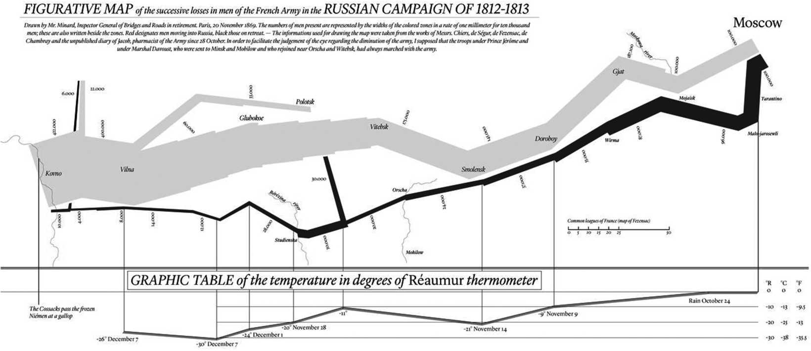

Napolion’s March to Moscow

FIGURE 1.4 Sample Data Visualization

## **Ronald T. Tolentino** *TUP / CS333*

## **Module 1: Wholeness of Data Analytics**

## Review Questions

1. Describe the Business Intelligence and Data Mining cycle.

**Is a broad set of IT solutions that includes tools for gathering, analyzing,**   
  **& reporting information to the users regarding the performance of the**   
  **organization & its environment**

1. Describe the data processing chain.  
   **Data -> Database -> Data Warehouse -> Data Mining -> Data Visualization**

**Raw Data from Sources and store it on Database. Clean and save it on**

**Data Warehouse to prepare for Data Mining and Data Visualisation.**

1. What are the similarities between diamond mining and data mining?  
   **Both Diamond Mining and Data Mining digs into vast amount of raw or unrefined ore/data to discover unique nontrivial useful patterns / gems.**
2. What are the different data mining techniques? Which of these would be relevant in your current work?
   * + ***Decision Trees***
     + ***Regression***
     + ***Artificial Neural Networks***
     + ***Cluster Analysis***
     + ***Association Rule Mining***

***Association Rule Mining and Cluster Analysis are relevant to my current work.***

1. What is a dashboard? How does it help?

**Dashboard are designed to provide visual information on a select few variables.**

**It helps deliver the information rapidly and in easy-to-grasp format.**

1. Create a visual to show the weather pattern in your city. Could you show together temperature, humidity, wind, and rain/snow over a period?

DUBAI Weather Averages

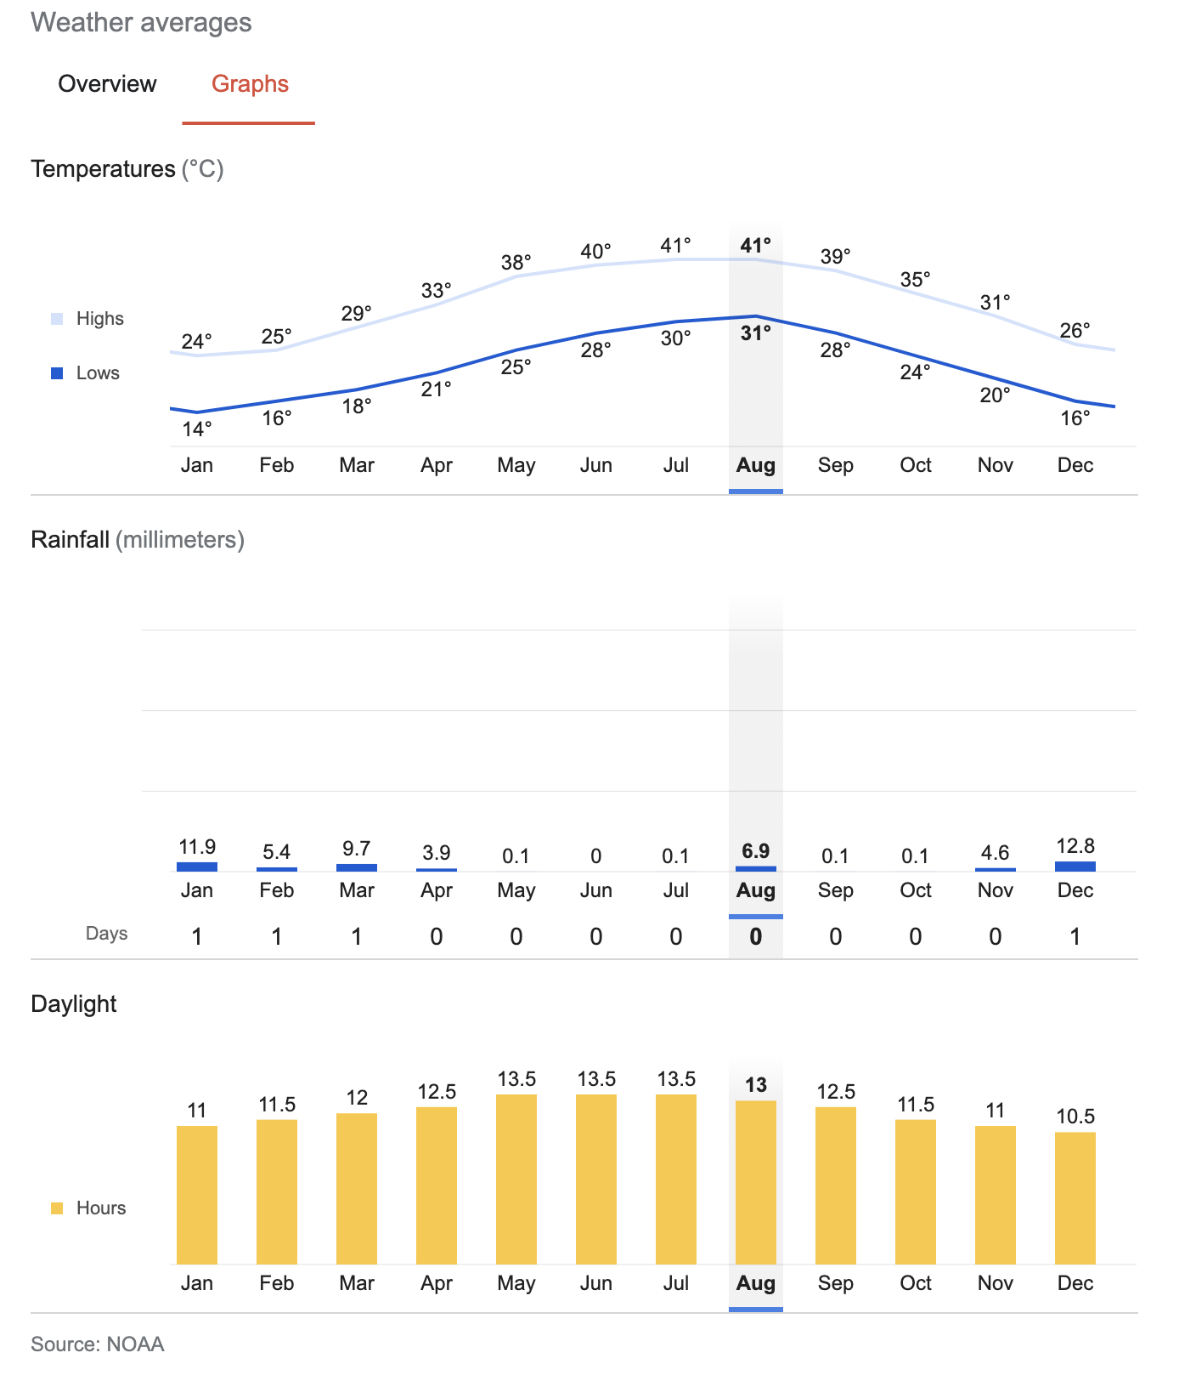

## True/False

1. Business intelligence is a measure of the intelligence of businesspeople. **False**
2. ‘Datafication’ means that without data one cannot do data mining. **False**
3. A pattern helps to grasp something abstract. **True**
4. In the context of pattern description, GAS stands for Good, Accurate and Simple. **False**
5. There is a sequence of steps to be followed to benefit from data in a systematic way. **True**
6. Selecting a good research question is an important part of doing a data mining project. **True**
7. Data warehouse is a method to archive the data for later use. **False**
8. Data for mining comes only from sources within the organization. **False**
9. The names and addresses of customers and employees are an example of ordinal data. **False**
10. Interval scale data is more amenable to analysis than the ratio data. **False**
11. Density of data storage in disk drives doubles every 5 years. **False**
12. A data warehouse is a more complex version of the operational database. **False**
13. Data should be analyzed at only the most detailed levels of granularity. **False**
14. Regression is the most popular and important data mining technique. **False**
15. Cluster analysis is a data mining technique for dividing and conquering large datasets. **True**
16. A good data visualization should present the conclusions and not just report the data. **True**
17. Big Data is a special type of data – very large, fast and complex. **True**
18. Social media interactions are a form of big data. **True**
19. A data analyst must have a computer science background. **True**
20. Data Science is a growing and multidisciplinary field. **True**